DATA HANDLING & VISUALIZATION

Class Activity 10.07.2026 - Complete Visualization Codes

Scenario 1 - Student Academic Performance
import pandas as pd
import seaborn as sns
import matplotlib.pyplot as plt
sns.set_style("whitegrid")
data={
'Student ID':[101,102,103,104,105,106,107,108,109,110],
'Attendance':[95,88,72,64,91,78,85,69,97,82],
'Marks':[92,84,70,62,95,76,81,68,98,80],
'Department':['CSE','AI','IT','ECE','CSE','AI','IT','ECE','CSE','AI']
}
df=pd.DataFrame(data)
plt.figure(figsize=(8,5))
sns.scatterplot(data=df,x='Attendance',y='Marks',hue='Department',palette='Set2',s=90)
plt.title('Student Academic Performance')
plt.tight_layout()
plt.show()
Output:
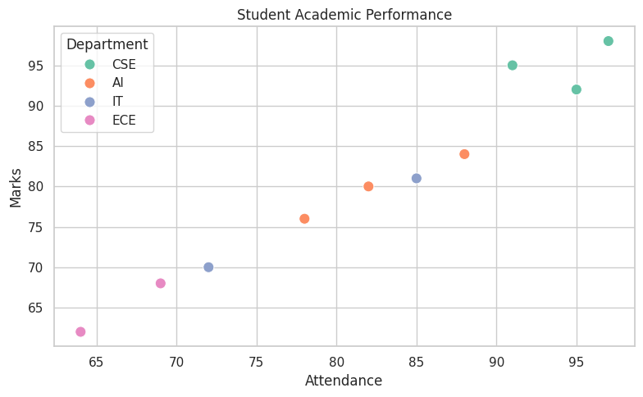

Scenario 2 - Electric Vehicle Market Analysis
import pandas as pd
import seaborn as sns
import matplotlib.pyplot as plt
sns.set_style("whitegrid")
data={
'Model':['M1','M2','M3','M4','M5','M6','M7','M8'],
'Battery':[30,40,50,60,70,80,90,100],
'Price':[12,16,20,28,35,42,50,60],
'Range':[220,280,330,380,430,500,580,650],
'Manufacturer':['MG','BYD','Hyundai','MG','Tesla','BYD','Tesla','Hyundai']
}
df=pd.DataFrame(data)
plt.figure(figsize=(8,5))
sns.scatterplot(data=df,x='Battery',y='Price',hue='Manufacturer',size='Range',sizes=(60,300))
plt.title('Electric Vehicle Market Analysis')
plt.tight_layout()
plt.show()
Output:
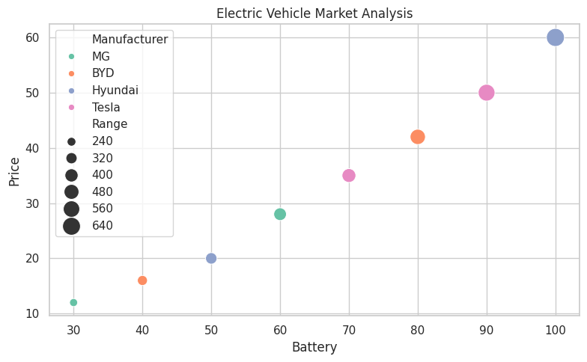

Scenario 3 - Hospital Patient Admission Analysis
import pandas as pd
import seaborn as sns
import matplotlib.pyplot as plt
sns.set_style("whitegrid")
df=pd.DataFrame({
'Department':['Cardiology','Orthopedics','Neurology','Pediatrics','General'],
'Patients':[180,140,90,160,220],
'Cost':[45000,38000,62000,28000,18000]
})
plt.figure(figsize=(8,5))
ax=sns.barplot(data=df,x='Department',y='Patients',hue='Department',palette='Set2',legend=False)
for i,row in df.iterrows():
ax.text(i,row['Patients']+3,f"₹{row['Cost']}",ha='center',fontsize=8)
plt.title('Hospital Patient Admissions')
plt.tight_layout();plt.show()
Output:
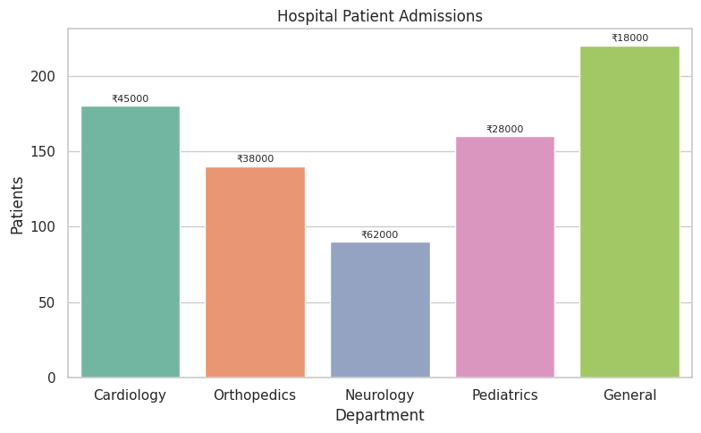

Scenario 4 - Weather Monitoring
import pandas as pd
import seaborn as sns
import matplotlib.pyplot as plt
sns.set_style("whitegrid")
df=pd.DataFrame({
'Day':[1,2,3,4,5,1,2,3,4,5,1,2,3,4,5],
'Temperature':[31,32,33,32,31,35,36,37,36,35,29,30,31,30,29],
'City':['Chennai']*5+['Delhi']*5+['Mumbai']*5
})
plt.figure(figsize=(8,5))
sns.lineplot(data=df,x='Day',y='Temperature',hue='City',style='City',markers=True,dashes=False)
plt.title('Weather Monitoring')
plt.tight_layout();plt.show()
Output:
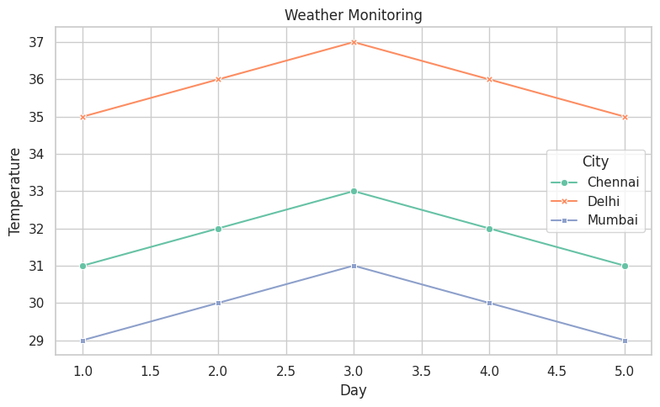

Scenario 5 - Supermarket Sales
import pandas as pd
import seaborn as sns
import matplotlib.pyplot as plt
sns.set_style("whitegrid")
df=pd.DataFrame({
'Category':['Electronics','Groceries','Fashion']*3,
'Branch':['A']*3+['B']*3+['C']*3,
'Sales':[450,300,250,420,340,280,480,320,310]
})
plt.figure(figsize=(8,5))
sns.barplot(data=df,x='Category',y='Sales',hue='Branch',palette='Set2')
plt.title('Supermarket Sales')
plt.tight_layout();plt.show()
Output:
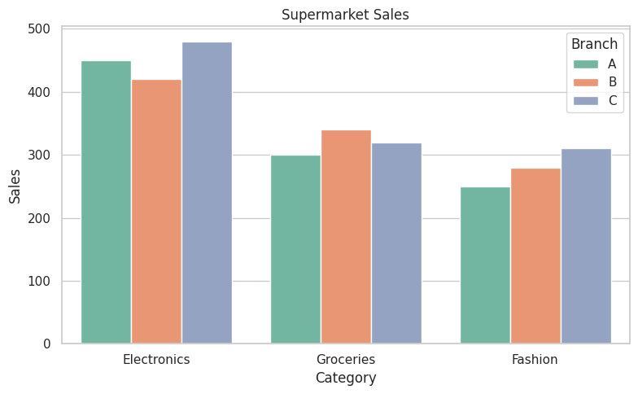

Scenario 6 - Employee Salary Distribution
import pandas as pd
import seaborn as sns
import matplotlib.pyplot as plt
sns.set_style("whitegrid")
salary=[32000,35000,38000,41000,45000,48000,52000,56000,60000,62000,65000,68000,72000,76000,80000]
plt.figure(figsize=(8,5))
sns.histplot(salary,bins=6,color='skyblue',edgecolor='black')
plt.title('Salary Distribution')
plt.tight_layout();plt.show()
Output:
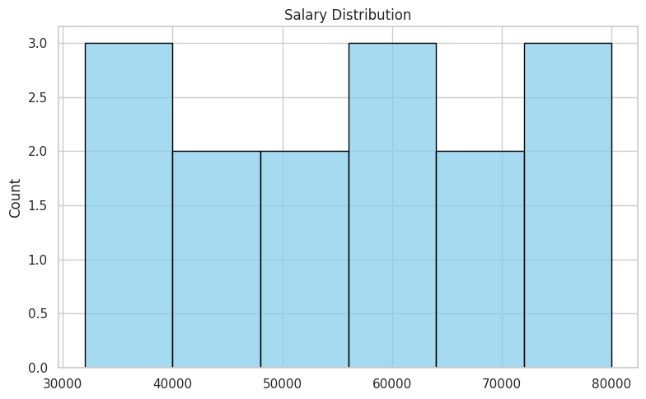

Scenario 7 - Smartphone Market Comparison
import pandas as pd
import seaborn as sns
import matplotlib.pyplot as plt
sns.set_style("whitegrid")
df=pd.DataFrame({
'Brand':['Samsung','Apple','OnePlus','Xiaomi','Samsung','Apple','OnePlus','Xiaomi'],
'RAM':[8,6,12,8,16,8,12,6],
'Processor':[2.6,3.2,3.0,2.8,3.3,3.4,3.1,2.7],
'Price':[30000,70000,45000,25000,80000,90000,50000,22000],
'Storage':[128,256,256,128,512,512,256,64]
})
plt.figure(figsize=(8,5))
sns.scatterplot(data=df,x='RAM',y='Price',hue='Processor',style='Brand',size='Storage',sizes=(80,250),palette='viridis')
plt.title('Smartphone Market Comparison')
plt.tight_layout();plt.show()
Output:
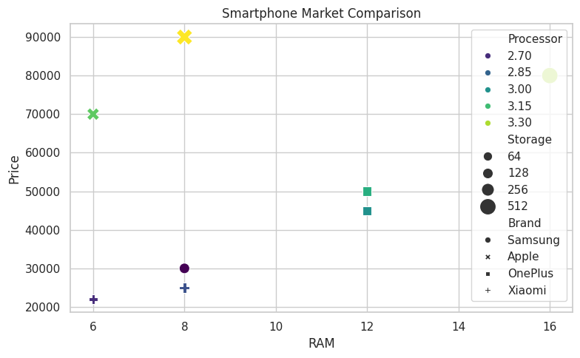

Scenario 8 - Movie Rating Analysis
import pandas as pd
import seaborn as sns
import matplotlib.pyplot as plt
sns.set_style("whitegrid")
ratings=pd.DataFrame({
2021:[4.2,3.8,4.0,4.5,3.6],
2022:[4.1,3.9,4.2,4.6,3.8],
2023:[4.3,4.0,4.1,4.7,3.9]},
index=['Action','Drama','Comedy','Sci-Fi','Horror'])
plt.figure(figsize=(6,4))
sns.heatmap(ratings,annot=True,cmap='YlGnBu')
plt.title('Movie Ratings')
plt.tight_layout();plt.show()
Output:
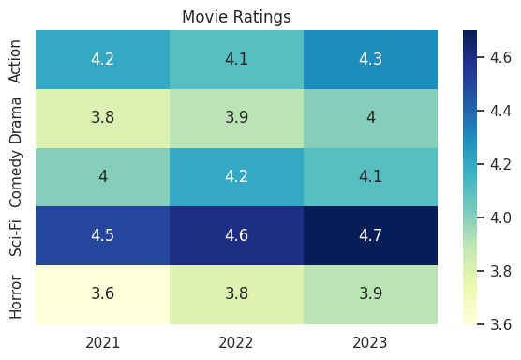

Scenario 9 - COVID-19 Analysis
import pandas as pd
import seaborn as sns
import matplotlib.pyplot as plt
sns.set_style("whitegrid")
df=pd.DataFrame({'State':['TN','KA','KL','MH','DL','AP'],
'Cases':[12000,9800,8600,25000,7400,6900]})
tile=df.set_index('State').T
plt.figure(figsize=(7,2))
sns.heatmap(tile,annot=True,cmap='Reds')
plt.title('COVID Active Cases')
plt.tight_layout();plt.show()
Output:
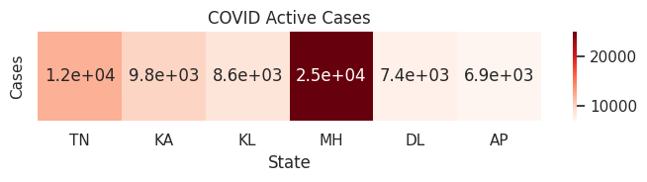

Scenario 10 - Iris Flower Classification
import pandas as pd
import seaborn as sns
import matplotlib.pyplot as plt
sns.set_style("whitegrid")
from sklearn.datasets import load_iris
iris=load_iris(as_frame=True)
df=iris.frame
df['Species']=df['target'].map({0:'Setosa',1:'Versicolor',2:'Virginica'})
plt.figure(figsize=(8,5))
sns.scatterplot(data=df,x='sepal length (cm)',y='petal length (cm)',hue='Species',style='Species',size='sepal width (cm)',sizes=(40,180))
plt.title('Iris Flower Classification')
plt.tight_layout();plt.show()
Output:
